AERO1005 MATLAB Coursework 2

Author: Yibo ZHU
Student ID: 20717674
Date of report: 2026/5/6

Task 1: READ TEMPERATURE DATA, PLOT, AND WRITE TO A LOG FILE
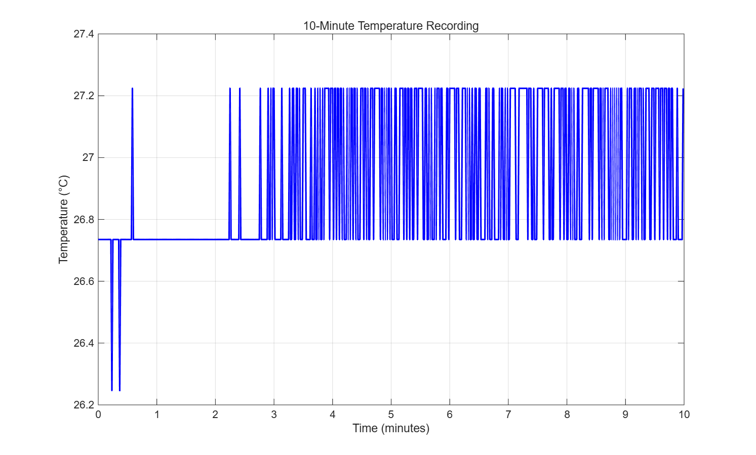
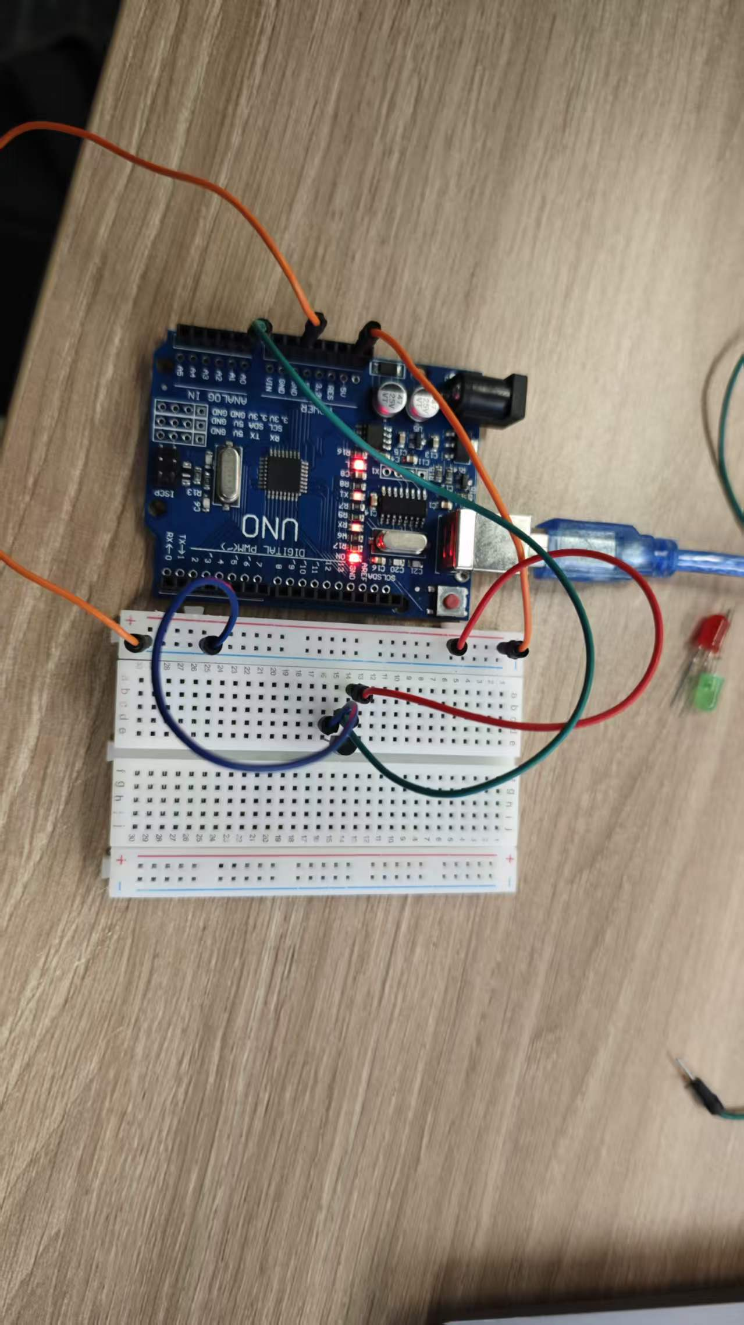

Task 2: LED TEMPERATURE MONITORING DEVICE IMPLEMENTATION
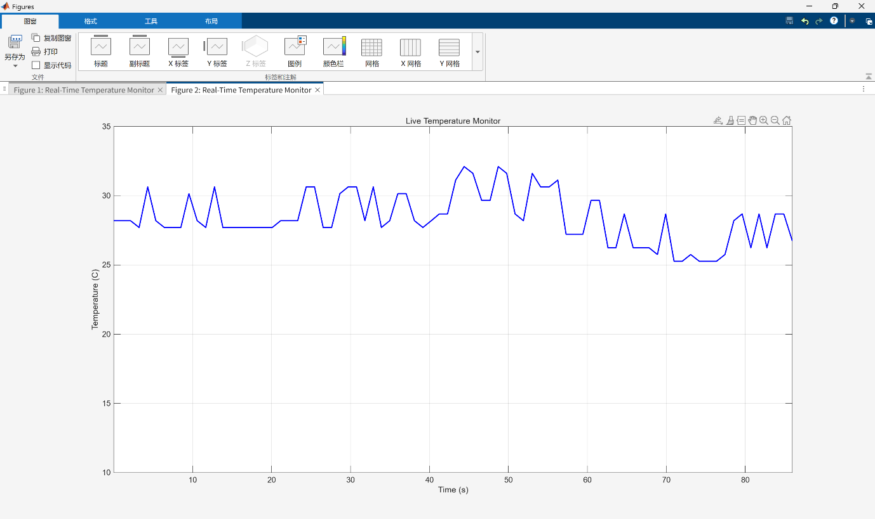
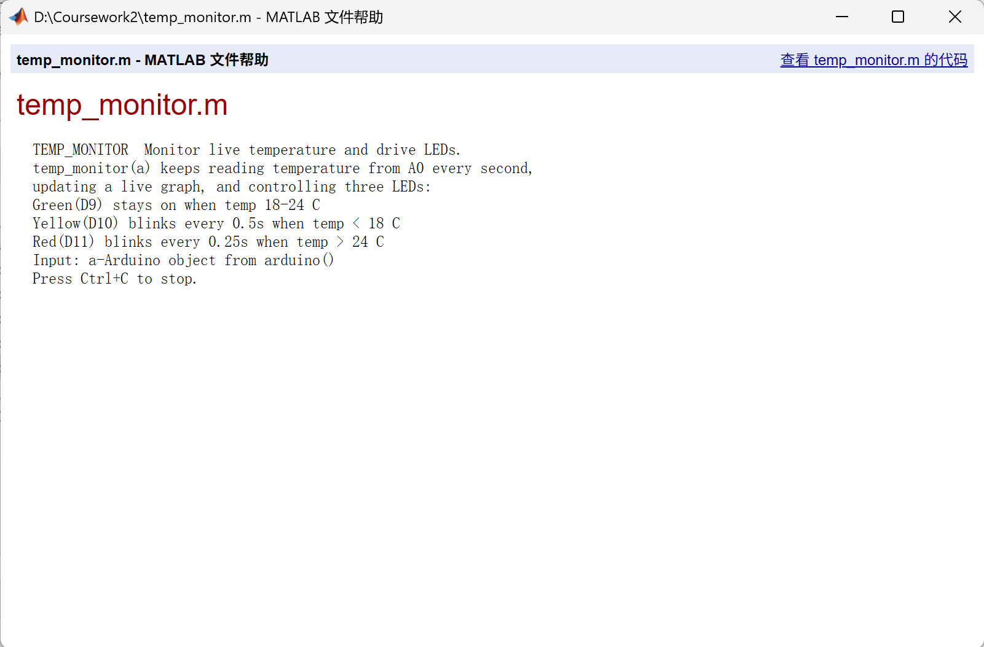
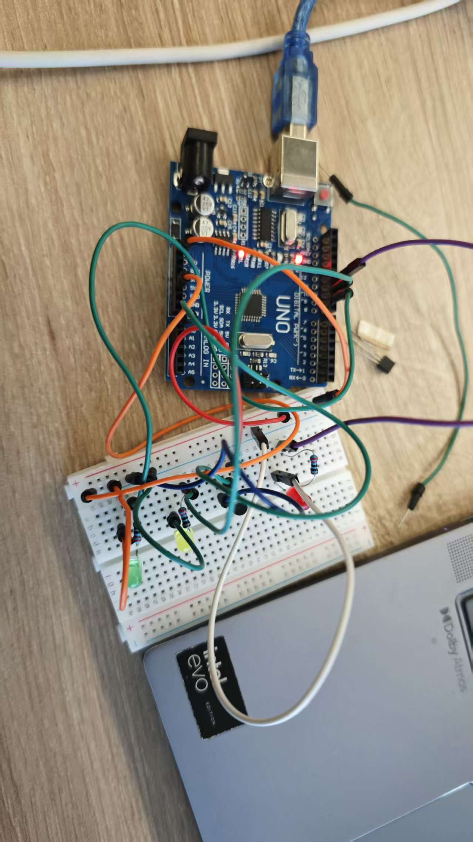

Task 2 Plan Flowchart：
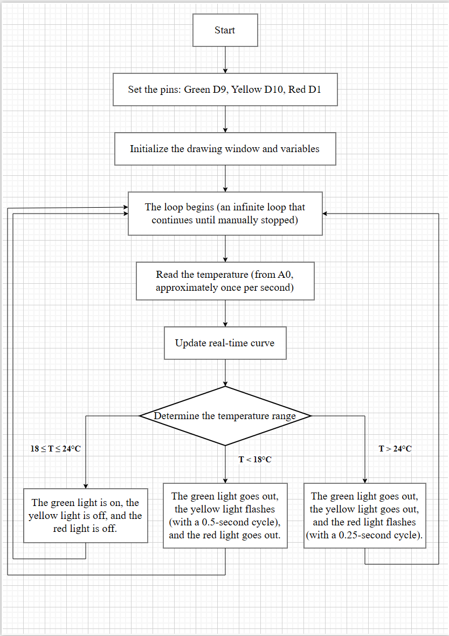

Task 2 Actual Flowchart：
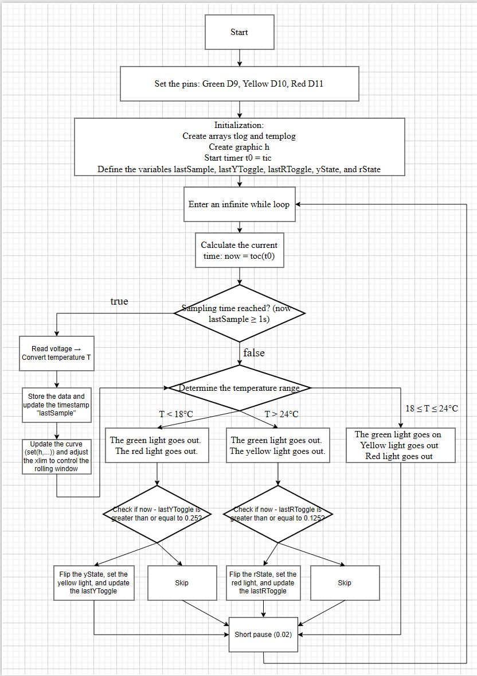

Task 3： ALGORITHMS – TEMPERATURE PREDICTION
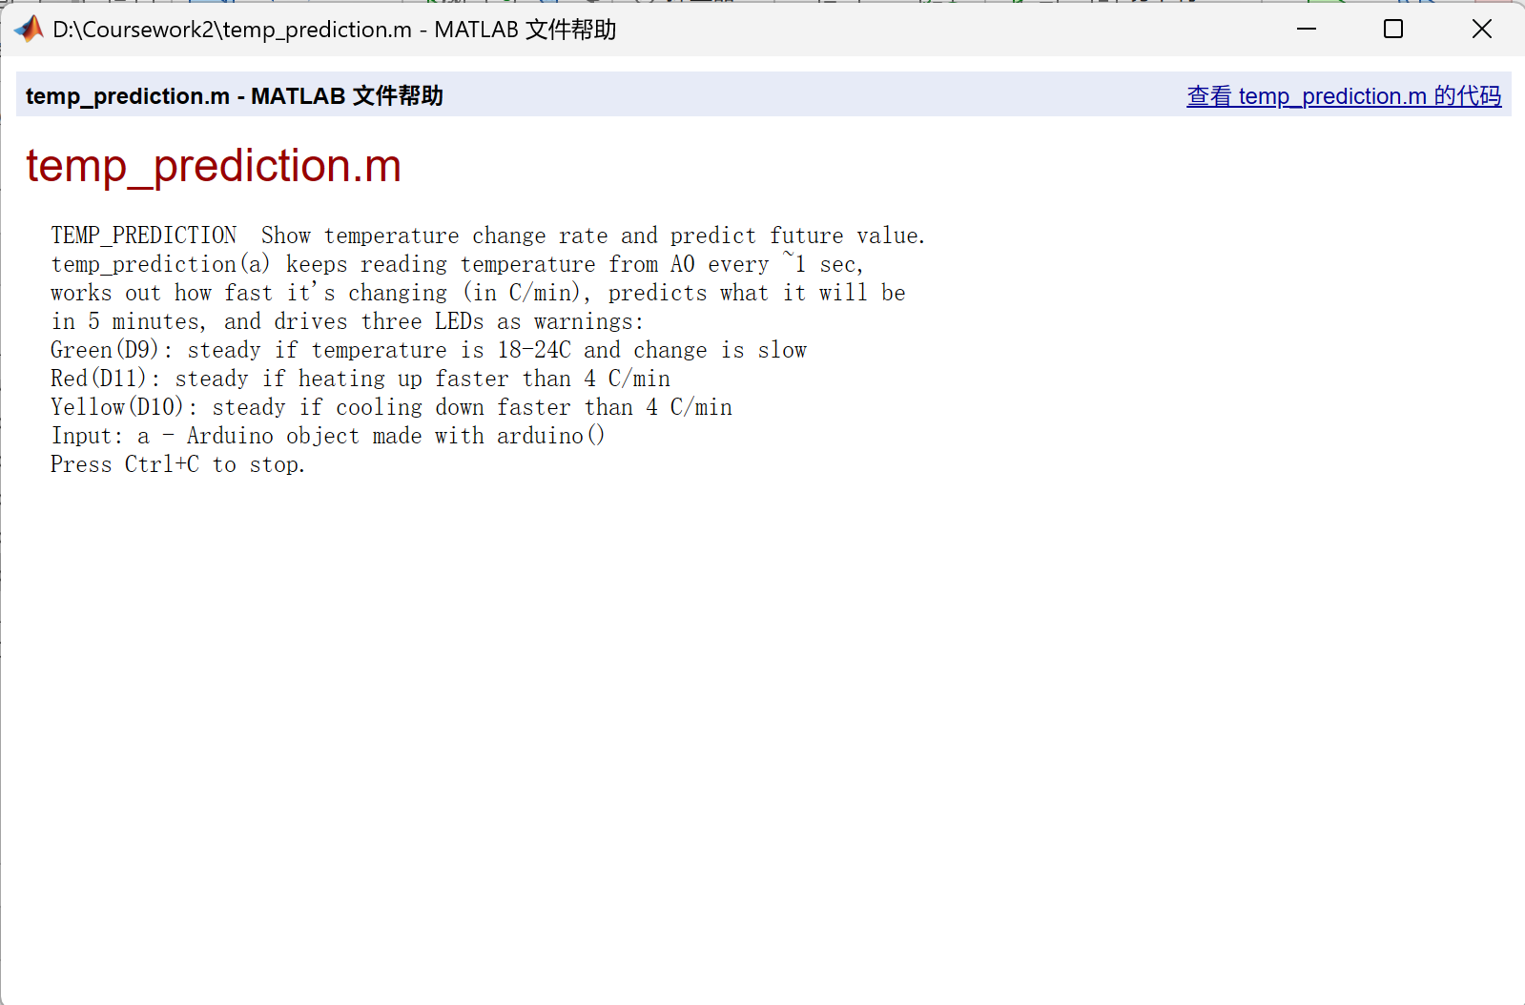
Green:
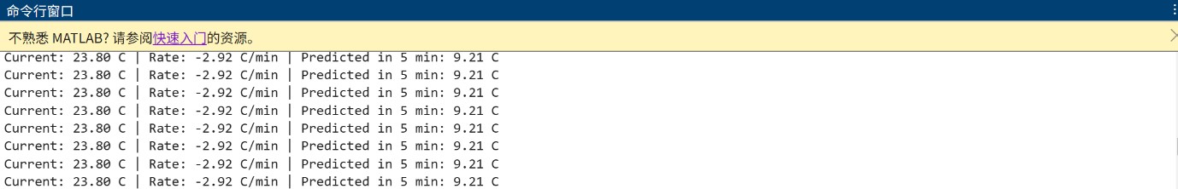
Red:
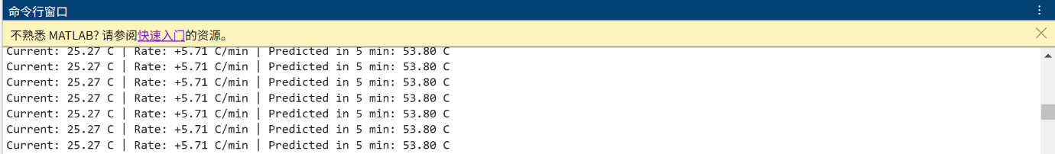
Yellow
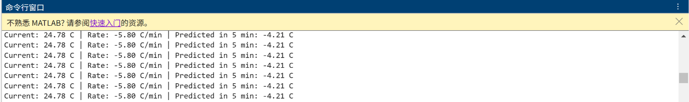

Task 3 Plan Flowchart：
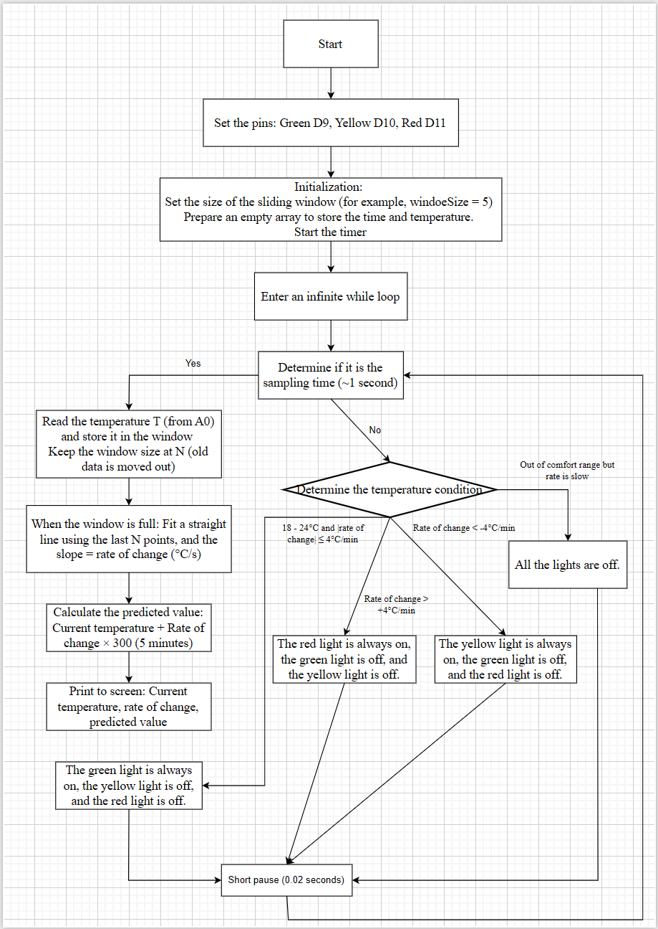

Task 3 Actual Flowchart:
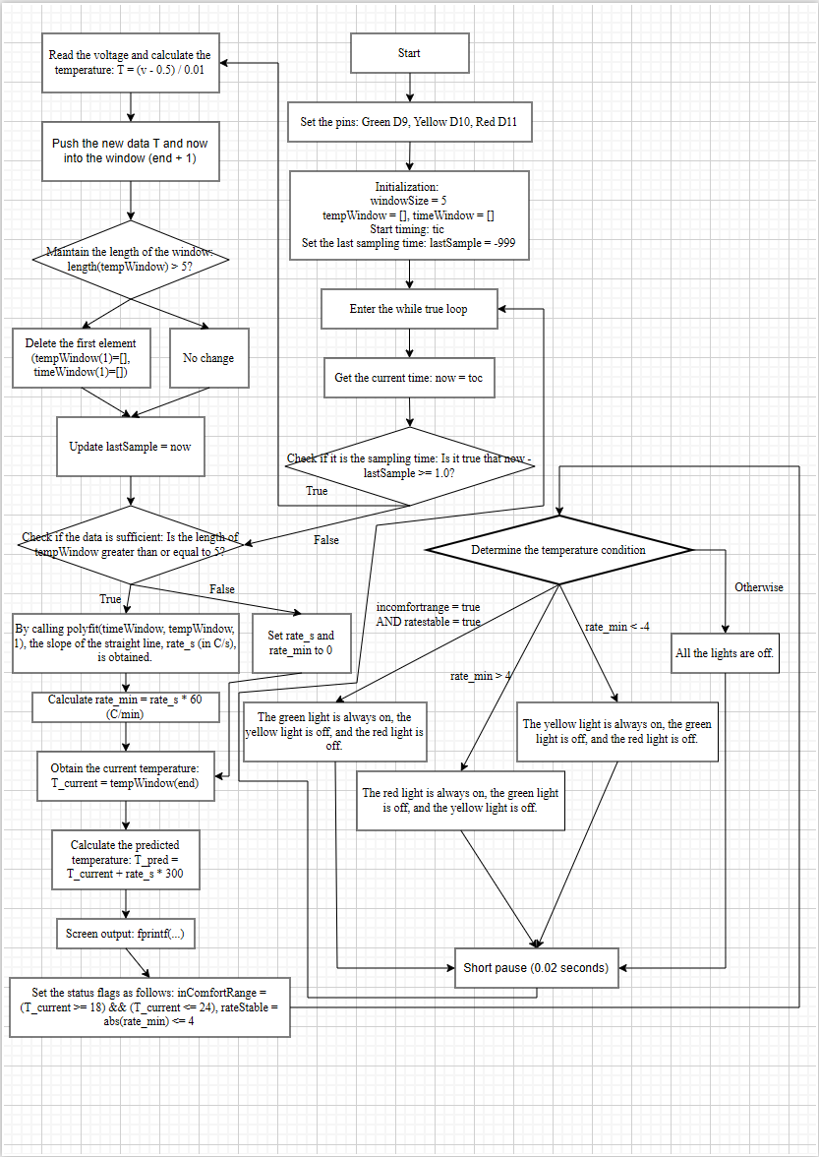

Task 4: REFLECTIVE STATEMENT

Throughout this project, I encountered both hardware and software challenges that deepened my understanding of data acquisition and control systems.

One of the most memorable difficulties happened right at the start of Task 1. After connecting the MCP9700A thermistor and running the acquisition code, I got readings around -41 °C, which was clearly wrong. I spent a long time checking the conversion formula and the Arduino connection before realising I had swapped the VDD and GND pins on the sensor. Once I corrected the wiring, the voltage from A0 returned to about 0.7 V and the temperature became a reasonable room value. This experience taught me how sensitive sensor circuits are and how important it is to check pinouts carefully.

Another challenge was coordinating the 1-second sampling interval with the LED blinking periods in Task 2. At first I tried using pause(1), but that made it impossible to achieve the 0.25 s and 0.5 s blink rates simultaneously. I learned to use tic/toc and separate timing variables to decouple the tasks, which made the system much more responsive.

For Task 3, calculating the rate of change was problematic because simply subtracting successive readings gave very noisy results. I therefore implemented a sliding window of five data points and used polyfit to fit a straight line. The slope of that line gave a much smoother derivative, although choosing the window size was a compromise between responsiveness and noise rejection.

I believe the strong points of my project are the complete implementation of all required functions, the clean separation into dedicated function files, and the reliable real-time performance. However, the prediction model is quite simple: it assumes the rate of change stays constant for five minutes, which is unrealistic in a real cabin. The system also lacks any recovery mechanism if the Arduino is accidentally disconnected.

In the future, I would like to add a small OLED display and a data logging function that saves historical records to a file would also make the system more practical and user-friendly.

